**Learning Outcomes**

1. Facebook Authentication using OAuth2

 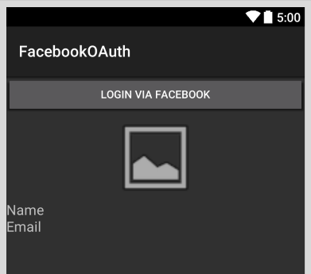

**To use the Facebook Graph API you need to first register your app on Facebook.**

1. Go to http://developers.facebook.com
2. Login using your facebook account
3. Go to My APPs and add a new App

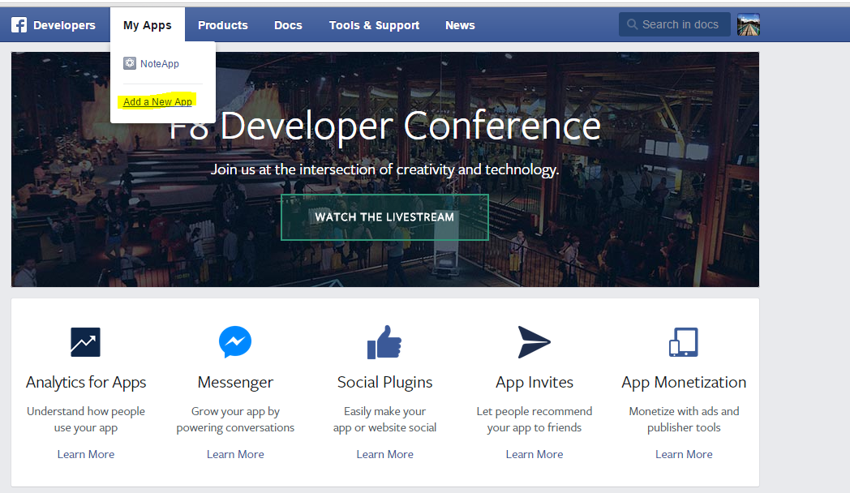

Select website

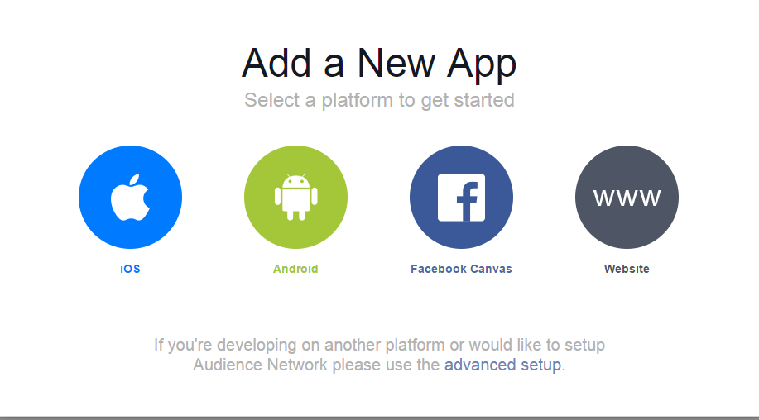

You need to provide a website

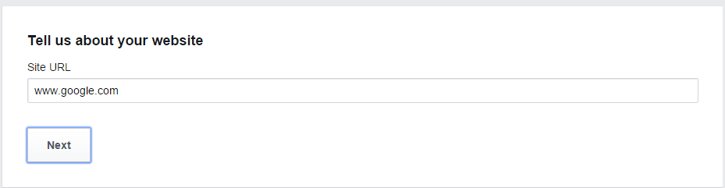

Select Your APP

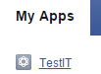

Take a note of your APP ID

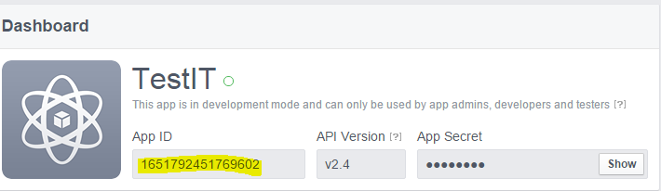

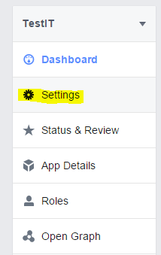

Click on Settings -> Advanced

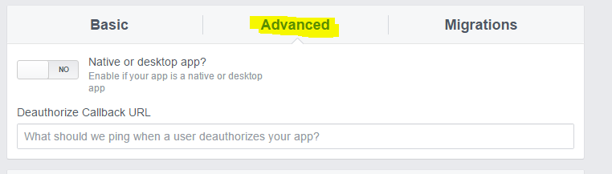

Scroll Down to Client OAuth Settings

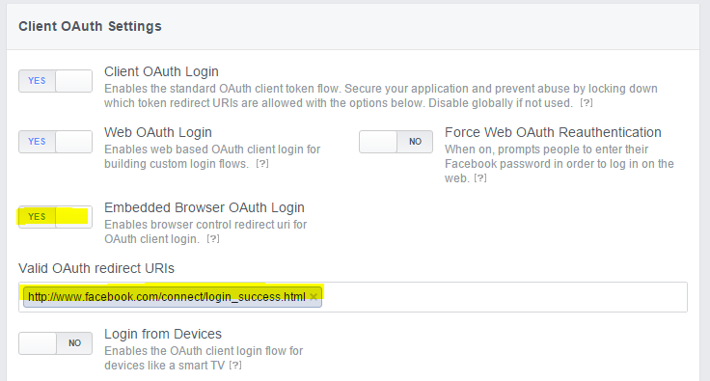

Save your changes

Include Xamarin.Auth and JSON.Net

MainActivity.cs

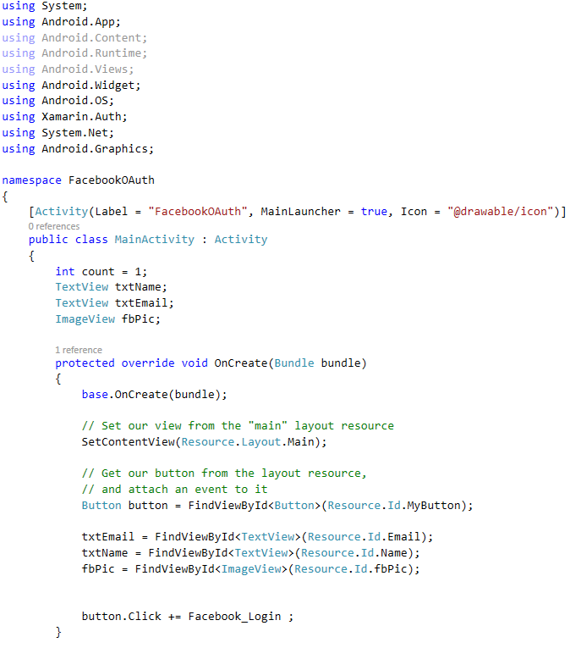

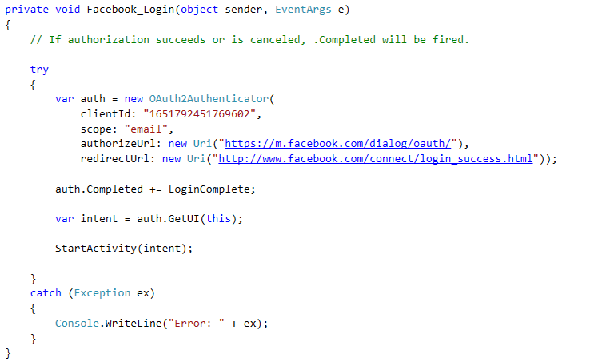

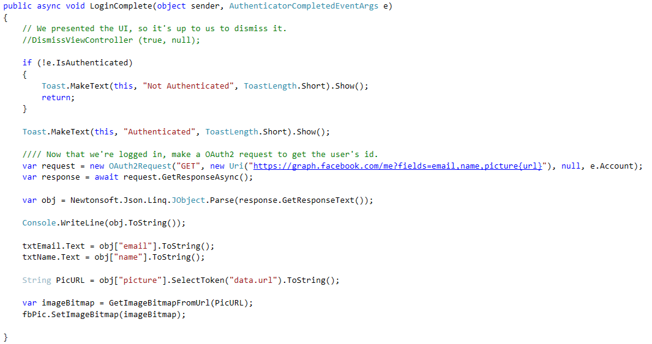

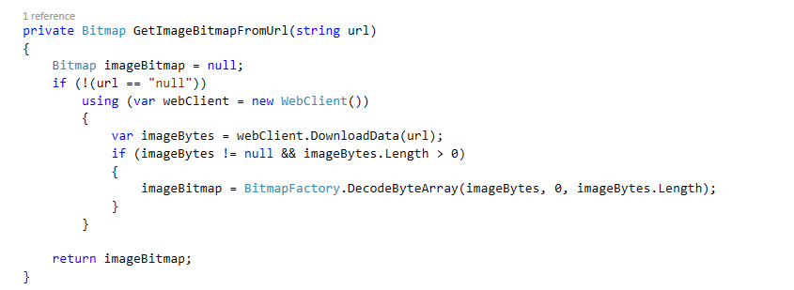

To understand the Facebook graph API

Go to

<https://developers.facebook.com/tools/explorer>.

